**Project Description**

ZeroWaste is a straightforward mobile app designed to boost productivity by allowing users to lock or time out distracting apps like social media and messaging. Ideal for students and professionals, it features customizable timers to prevent interruptions during work or study sessions. With minimal data usage and a user-friendly interface, ZeroWaste helps users manage digital distractions effectively, promoting focused tasks and improved productivity.

**Requirements Summary**

|  |  |  |
| --- | --- | --- |
| **MINIMUM REQUIREMENTS** | Processor Cores | Single Core |
| OS | Android 4.4 (KitKat) |
| RAM | 2 GB |
| **RECOMMENDED REQUIREMENTS** | Processor Cores | Quad Core |
| OS | Android 8.0(Oreo) |
| RAM | 4 GB |
| **OTHER REQUIREMENTS** | Permissions | Notifications and Storage |

Table 1. System Requirements

To cater to low-end android models, the application will have at most a minimum of 1 Core, 2 GB worth or RAM, and Android version 4.4 or KitKat as its OS. The app itself is not at all demanding, hence our team has settled on lower requirement specs.

**Overview**

We conducted a remote usability evaluation of the ZeroWaste prototype with 15 college student participants. The evaluation consisted of task-based usability testing, heuristic evaluation, and user surveys. The goal was to assess the effectiveness, efficiency, and user satisfaction of the prototype, and identify areas for improvement.

**Method of Conducting Prototype Tests**:

The team will conduct this evaluation through online social media platforms such as Discord. This is to ensure that the pair will still be able to see a live feed of what is currently happening in the prototype.

The Evaluation section is split into three separate parts: Usability Specifications, Heuristics Evaluation, and Participant Survey and Feedback. Below is a table describing each technique.

|  |  |
| --- | --- |
| **Technique** | **Description** |
| Usability Specifications | Usability Specifications is the technique used to evaluate the level of usability that the Prototype has. It consists of tasks that will be done by Participants. Furthermore, the Technique will contain timing the speed of the participants at a given task. The tasks will be split into 3 Sections: Start Menu, App Selection Task, Timer Setting Task. This task is chosen to properly identify what flaws are seen when the user interacts with the prototype and how easy it is to use said prototype. |
| Heuristics Evaluation | Heuristics Evaluation will assess the UX design of the ZeroWaste prototype against industry-standard usability principles. This technique is chosen to provide a quick and accessible way to evaluate the validity of the prototype's design, particularly when time or resources are limited. |
| Participant Survey and Feedback | After interacting with the prototype, participants will be given a survey. The survey will contain quantitative questions interpreted on a 5-point Likert Scale and qualitative questions in the form of open-ended feedback. This approach ensures that no designer bias influences the results of this evaluation. |

The tasks will be split into three sections: Main Menu Task, App Selection Tasks, and Timer Setting Tasks. Below are some of the tasks that the selected participants will be asked to perform for each Section to showcase the Prototype’s functionality:

* **Start Menu Task**

Participants will navigate the start menu and press the “Start” button to get started with the application.

* **App Selection Tasks**

Participants will select various apps to lock and manage distractions, testing the intuitiveness and efficiency of the selection process.

* **Timer Setting Tasks**

Participants will set timers to lock selected apps, assessing the ease and clarity of the timer functionality.

The previously mentioned tasks were designed in a specific way to accommodate the user in terms of:

**User Friendly UI**

* Ensuring that the interface is intuitive and easy to navigate.
* Using clear and simple icons and labels for better understanding.

**Simple App Mechanism**

* Simplifying the process of selecting apps and setting timers.
* Minimizing the number of steps required to complete each task.

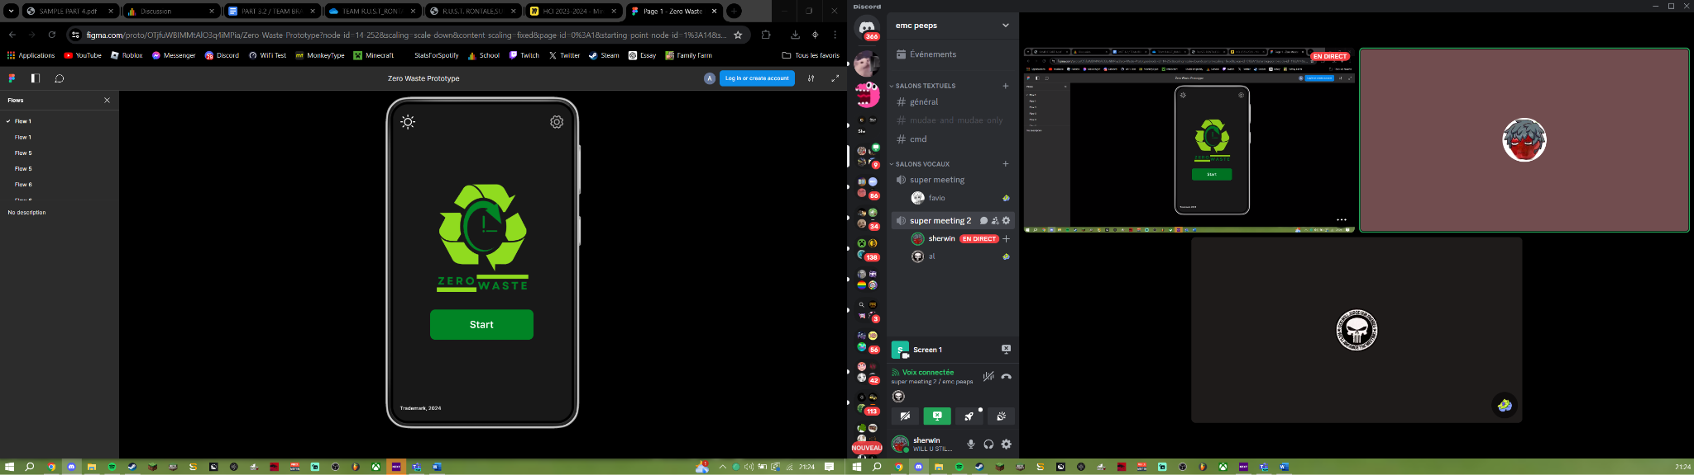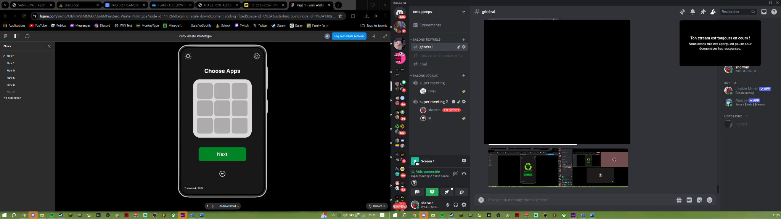

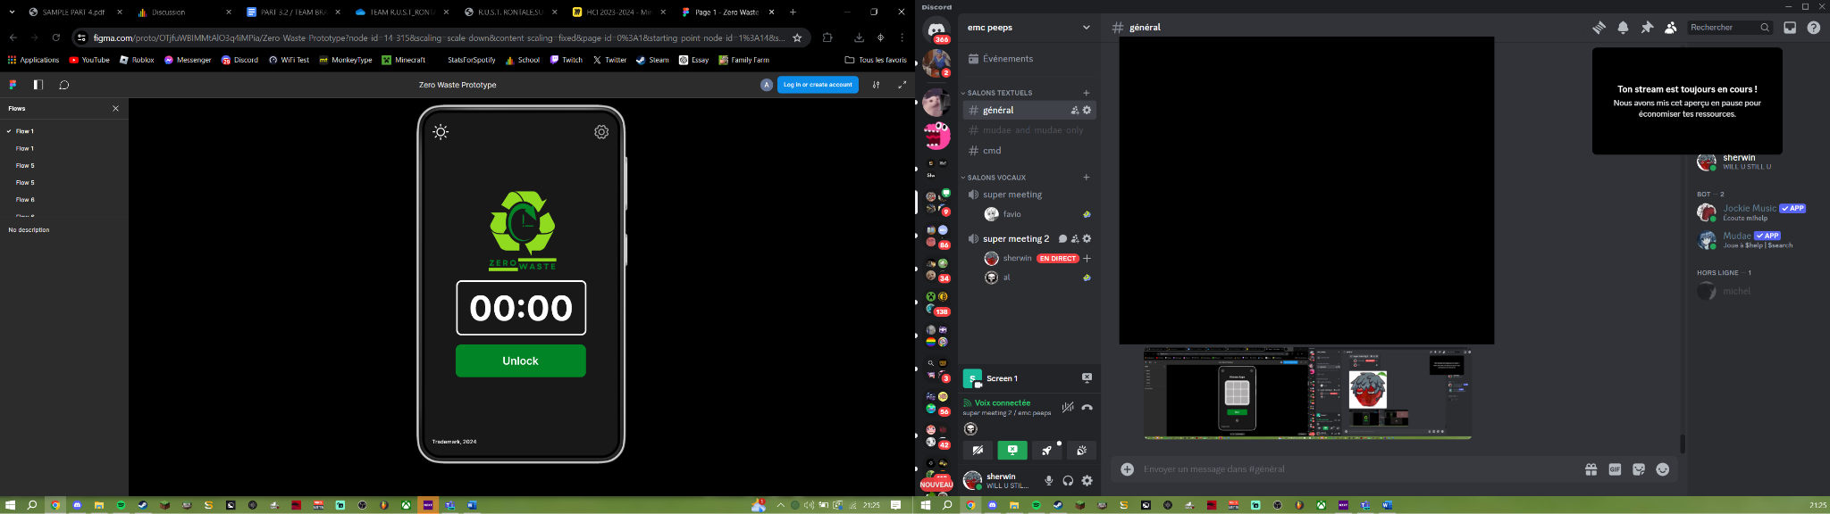

**DISCORD CALL**

**Data Presentation**

**Data Analysis**

**Usability Specifications**

Based on observations made by Team Brain Rot, users of the ZeroWaste application have been interacting with it successfully throughout the testing stage. A majority of the users demonstrated a natural comprehension of the app's functionality by finishing their assignments with ease. The app's navigation was easily mastered by users, who discovered that it was easy to use and had a good distractibility reduction impact. Nevertheless, some participants experienced issues with the app lock feature, meaning that some apps did not lock as intended. These issues seem to be minor bugs that can be fixed to increase the app's dependability. ZeroWaste has a lot of promise in helping consumers increase their productivity because of its capacity to lessen distractions.

|  |  |  |  |
| --- | --- | --- | --- |
| **Task** | **Mean** | **Interpretation** | **Classification** |
| Start Menu Task | 0.16 Minutes | Highly Acceptable | Successful |
| App Selection Task | 1 Minute and 30 Seconds | Highly Acceptable | Successful |
| Timer Setting Task | 0.5 Minutes | Highly Acceptable | Successful |

Table 3. Tasks and Results

Table 3 shows the results while the online testing was done. The data shows that each participant was able to successfully accomplish each task.

* **Heuristic Evaluation**

The ZeroWaste prototype will be evaluated within each type of heuristic evaluation.

### **Visibility of System Status**

The prototype effectively informs participants about the current status and ongoing processes within the prototype. Clear indicators and feedback mechanisms are in place to keep users informed.

### **Match Between System and Real World**

The prototype uses simple, clear English that is easily understood by participants of all ages. Words and phrases are chosen to be relatable and easily comprehensible.

### **User Control and Freedom**

The prototype includes fail-safes such as a back button to allow participants to correct mis-clicks or exit tasks they do not understand. Back buttons are also implemented as an additional safety measure.

### **Consistency and Standards**

The prototype maintains a high level of consistency, although there are minor issues such as the inconsistent positioning of back buttons and unclear tapping locations that need to be addressed.

### **Error Prevention**

The prototype incorporates mechanisms to prevent errors, although minor errors do occur and affect the user experience. These issues are noted and will be addressed in future iterations.

### **Recognition Rather Than Recall**

Options, objects, and actions are clearly visible and accessible, reducing the need for users to recall information from memory during interactions.

### **Flexibility and Efficiency of Use**

The prototype is designed to be easily understood and used proficiently by both experienced and inexperienced users. Its straightforward interface supports quick and efficient use.

### **Aesthetic and Minimalist Design**

The prototype features a sleek, modern, minimalist design. Unnecessary information is omitted to keep the interface clean and focused on essential functions.

### **Help Users Recognize, Diagnose, and Recover from Errors**

While the prototype indicates when users click on non-interactive areas, it lacks comprehensive support for helping users recognize, diagnose, and recover from errors in plain language.

### **Help and Documentation**

Users can access help or assistance from the present team members, although formal help and documentation are limited and should be improved.

### **Heuristics Conclusion**

Overall, the ZeroWaste prototype meets most heuristic evaluation criteria with some issues that need to be addressed. These findings will guide future improvements to enhance the prototype's usability.

***Participant Survey and Feedback***

|  |  |  |  |
| --- | --- | --- | --- |
| SECTION 1 | | | |
| Question | Mean | Interpretation | Classification |
| On a scale from 1-5 how would you rate your experience with ZeroWaste? | 4.81 | Highly Acceptable | Successful |
| On a scale from 1-5 how would you rate the UI design of ZeroWaste? | 4.45 | Acceptable | Successful |
| How easy was it to follow the provided tasks/navigate ZeroWaste | 4.02 | Acceptable | Successful |
| SECTION 2 | | | |
| Start Page | 4.69 | Highly Acceptable | Successful |
| Choose Apps Page | 4.01 | Acceptable | Successful |
| Set Timer Page | 4.76 | Highly Acceptable | Successful |
| Unlock Apps Page | 4.66 | Highly Acceptable |  |
| Settings Page | 3.90 | Moderately Acceptable | Neutral |
| Choose Alarm Page | 4.12 | Acceptable | Successful |
| Set PIN Page | 4.32 | Acceptable | Successful |
| Send Feedback Page | 4.51 | Highly Acceptable | Successful |

Table 4. Data Interpretation

Two sections of the table display the findings from user assessments of the ZeroWaste application. Section 1 covers overall experience, UI design, and task easiness, each assessed on a scale of 1 to 5. These aspects typically received scores around 4, classed as "Acceptable" and "Successful." Section 2 evaluates individual pages, such as the Start Page, Choose Apps Page, Set Timer Page, and others. All pages had an average score of 4.33, indicating overall success. The scores ranged from 3.90 to 4.81, with most pages being evaluated as "Highly Acceptable" and "Successful," except for the Settings Page, which was rated as "Moderately Acceptable" and "Neutral."

**Feedback**

While most of the feedback was overwhelmingly positive, some participants highlighted a few issues. Common concerns revolved around the Settings Page of the ZeroWaste application. These issues raised concerns that navigating and utilizing the Settings Page was somewhat difficult to follow. This feedback indicates a need for refinement in this area to ensure a more seamless user experience.

* **Does your prototype need to be altered to address the results of the analysis, or was it completely successful?**

It was completely successful. From the data gathered, the participants were satisfied with what was given to them, meaning that there is no need to alter/change the prototype.

* **What improvements could be made to the design to address any shortcomings?**

Improvements could be made by enhancing the quality of the Settings Page to make it more visually appealing and user-friendly.

* **Did you discover any major flaws that would suggest a completely different type of design?**

No major flaws were discovered that would suggest the need for a completely different type of design for ZeroWaste.

**Critique & Summary**

**What were the advantages and disadvantages of your evaluation?**

The evaluation came with a number of advantages and disadvantages. In a positive way it offered thorough feedback on a range of application characteristics, highlighting its strong points, including functionalities that are easy for users to use and efficient features. This feedback verified that the main idea and design strategy were successful in lowering distractions and brought up particular areas for improvement, such as the Settings Page. But there were also certain drawbacks. The evaluation's narrow focus may have prevented it from addressing certain user scenarios or particular demands because it did not include a wide range of demographics.

**What would you have done differently knowing what you know now (both design wise and evaluation-wise)? Given more resources, what could you have done that would have produced significantly more insightful evaluation results (again, whether this is an improved prototype or a different evaluation path).**

With the knowledge we currently have, we would have prioritized improving the Settings Page's usability and simplicity right away, taking feedback from users into account early in the design phase. We would have employed a more varied set of participants in the review process and combined quantitative and qualitative techniques, such in-depth interviews, to obtain deeper insights. With greater investment, we could have created a more sophisticated prototype with interactive elements and carried out more rounds of user testing to guarantee a polished and user-focused finished result.

**Summary of the Project**

With ZeroWaste, users can lock or set time limits on distracting apps like chat and social networking, which helps users increase productivity. With programmable timers to avoid disruptions during work or study sessions, it is designed with professionals and students in mind. ZeroWaste successfully lowers digital distractions, encouraging concentrated work and increased productivity with its simple layout and user-friendly UI.

Based on our ZeroWaste usability test results, we recommend adding continuous user feedback channels to tweak and improve app features as user preferences change. Increasing collaboration with educational institutions and productivity specialists will widen app integration options and improve support services. To assist users in increasing productivity, we advocate developing accurate user education programs.